# 🚑 Healthcare Analysis Report

✨ What if hospital leaders could **see revenue flow, provider performance, and patient satisfaction — all in one place**?

I recently worked on a **Power BI healthcare dashboard (sample data: 2024–2025)** that transforms raw hospital records into **actionable insights for smarter decision-making**.

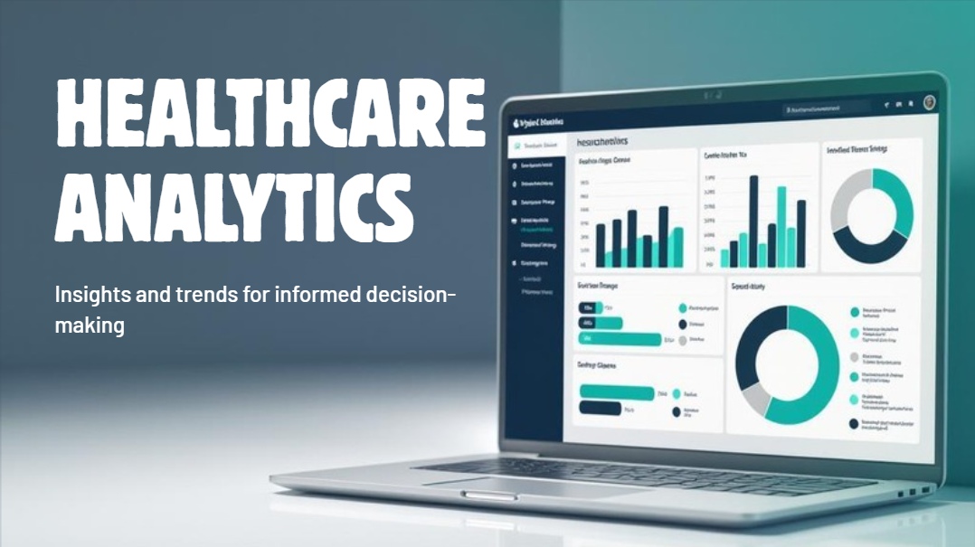

🏥 **Business Case & Problem Solved**  
Hospitals often face challenges such as:  
• Revenue scattered across treatments, medications, insurance, and room charges  
• No clear way to measure provider performance  
• Difficulty comparing results across time, departments, or locations

This dashboard brings **all these metrics together**, helping management make **data-driven decisions** about operations, finance, and patient care.

📈 **Objectives**  
• Consolidate financial and operational data in one dashboard  
• Track revenue by treatment, insurance, medication, and rooms  
• Measure provider efficiency, patient satisfaction, and treatment effectiveness  
• Identify trends over time for better planning  
• Enable side-by-side comparison of doctors and departments

⚙️ **Process (ETL & Data Modeling)**  
• **Extract:** Excel sheets (patients, visits, providers, insurance, diagnoses, procedures, departments, cities)  
• **Transform:** Cleaned in Power Query (fixed data types, handled nulls, standardized values)  
• **Load & Model:** Created a **data blueprint connecting all points** — Visits as the fact table + dimensions for patients, providers, procedures, departments, insurance, and cities.

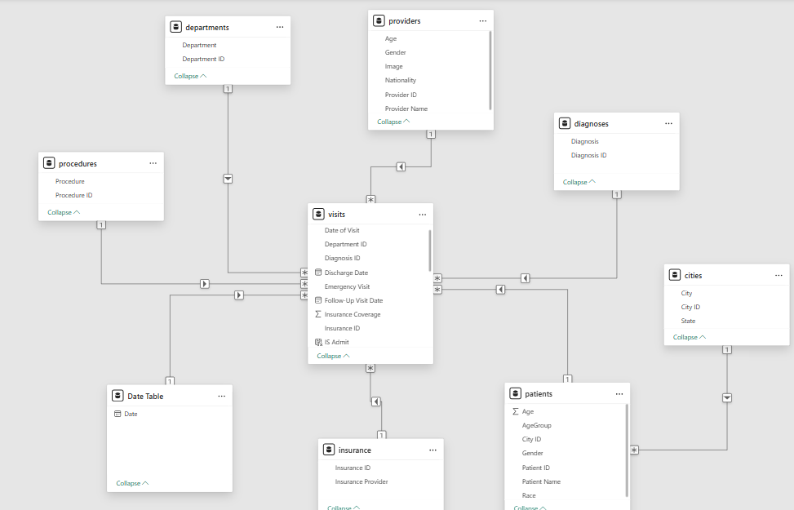

i) Snowflake schema - Data Modeling

🤔 **Key Business Questions Answered**  
• Where is the hospital revenue coming from?  
• Which procedures generate the most income?  
• How efficient are doctors in terms of patient care, stay duration, and revenue?  
• How is patient satisfaction trending over time?  
• Which departments or cities are performing best financially?  
• How do providers compare in revenue, satisfaction, and efficiency?

📊 **Dashboard Walkthrough & Insights**

**1️. Financial Overview — “Where is the money coming from?”**

* **KPIs:** Total Revenue, Treatment Revenue, Medication Cost, Insurance Revenue, Rooms Revenue
* **Insights:**  
  • 56% of revenue comes from treatment charges; 8% from room charges  
  • Insurance contributes 23% of collections (AXA largest share)  
  • CT Scans & X-rays are top revenue-generating procedures  
  • Edinburgh & Birmingham lead city-wise revenue

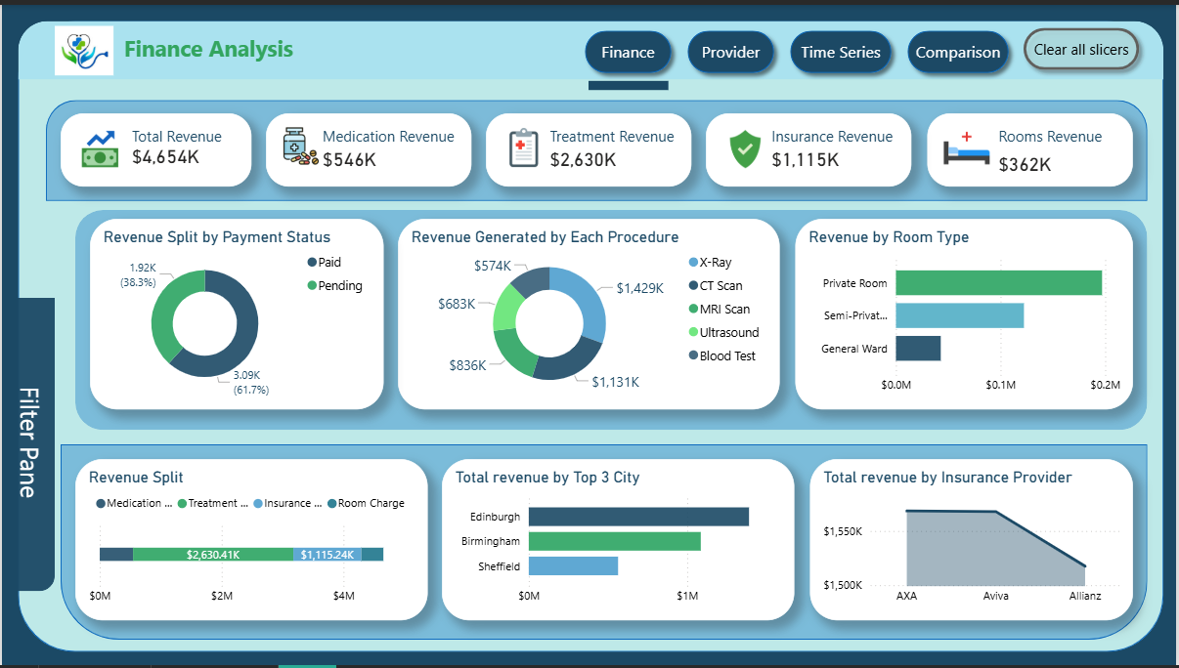

**2️. Provider Performance — “Which doctors are performing best?”**

* **KPIs:** Total Patients, Avg Satisfaction Score, Avg Medication Cost, Revenue
* **Insights:**  
  • Dr. Sade treated the most patients but satisfaction slightly lower (2.7/5)  
  • Dr. Johnson Grek achieved highest satisfaction (5/5) with fewer patients → strong quality focus  
  • Emergency visits = 38% of total cases, higher in cardiology & orthopaedics

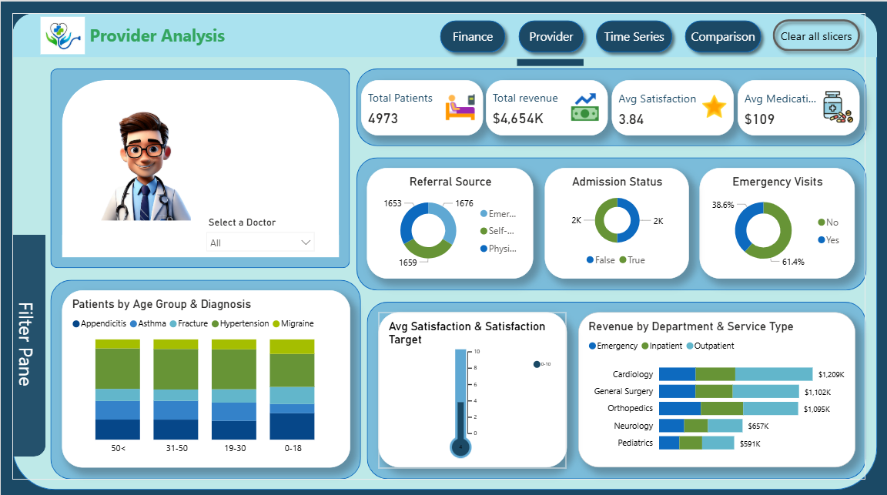

**3️. Time Series Analysis — “Is the hospital growing?”**

* **KPIs:** Revenue % showing for ->YoY, MoM, QoQ
* **Insights:**  
  • Revenue is down 64% YoY.  
  • Seasonal dip in Q4 for patient count; room revenue stable  
  • Satisfaction improved from 2024 to 2025  
  • Outpatient visits increase steadily; inpatient stays are stable — helps with bed allocation planning

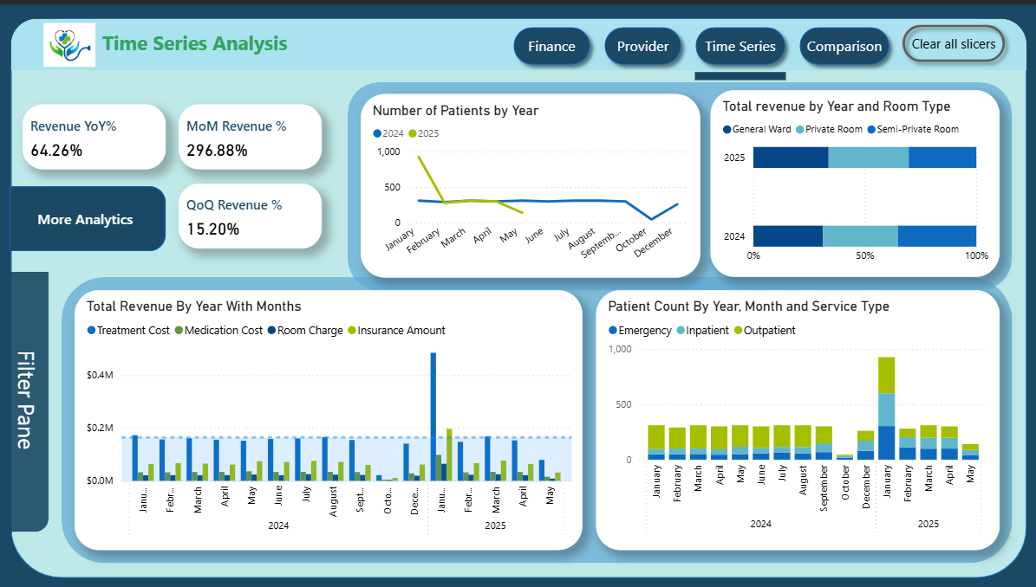

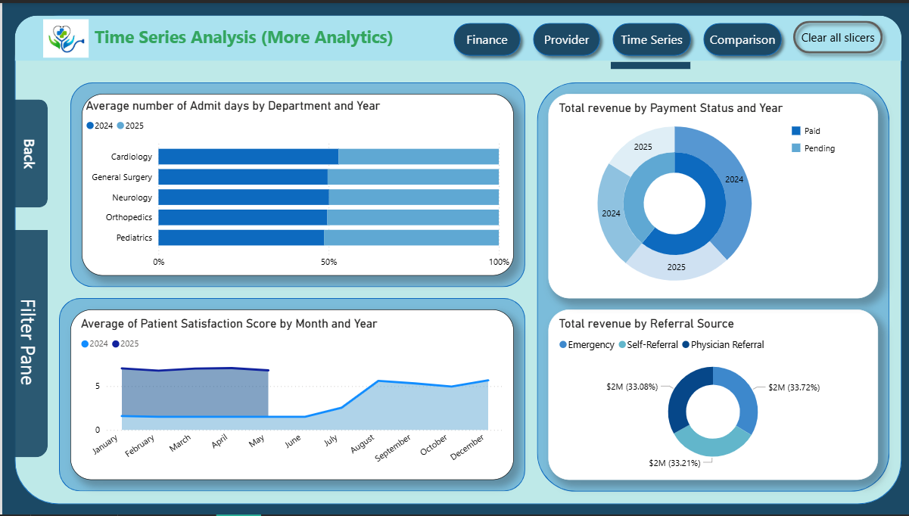

**4️. Provider Comparison — “How do doctors compare?”**

* **Insights:**  
  • Dr. Olu generates highest revenue per patient.  
  • All the providers take average 5 days to cure Diagnosis.  
  • Diagnosis cases: Dr. Olu discharges faster; Dr. Emma’s patients stay longer  
  • Satisfaction gap: Dr. Emma (2/5) vs Dr. Olu leads (3/5) vs Dr. Ravi (2/5)

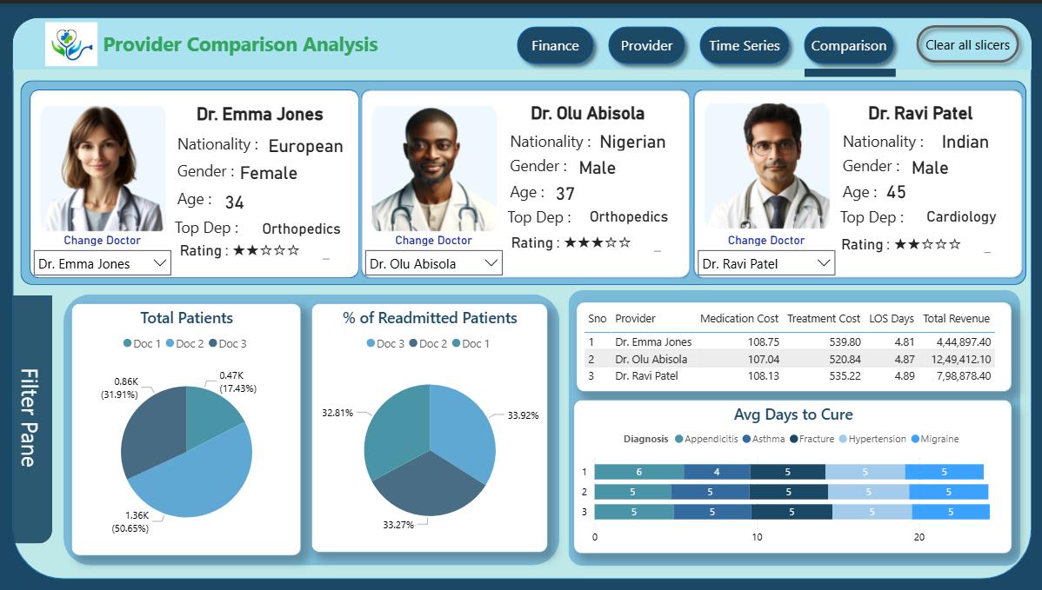

### ****5. Interactive Filter Panel****

* A **common filter panel** is available on all pages for easy exploration.
* **How it works:**
  + Click the **“Filter Panel” button**
  + Panel slides open horizontally across the page
  + Contains multiple filters: **City, Payment Status, Year-Month, Referral Source, Admission Status, Department**, etc.
  + Users can **adjust filters on the fly** to see updated KPIs and charts

## 📝 Summary & Business Value

This dashboard shows how **raw hospital data is transformed into actionable insights**. By connecting, cleaning, and modeling data, it provides a **single view of revenue, provider performance, and patient experience**.

The analysis enables **data-driven decisions**, helping management optimize revenue, doctors benchmark performance, insurance partners understand coverage impact, and patients receive better care.